13. Plot of a Hoeppener Diagram
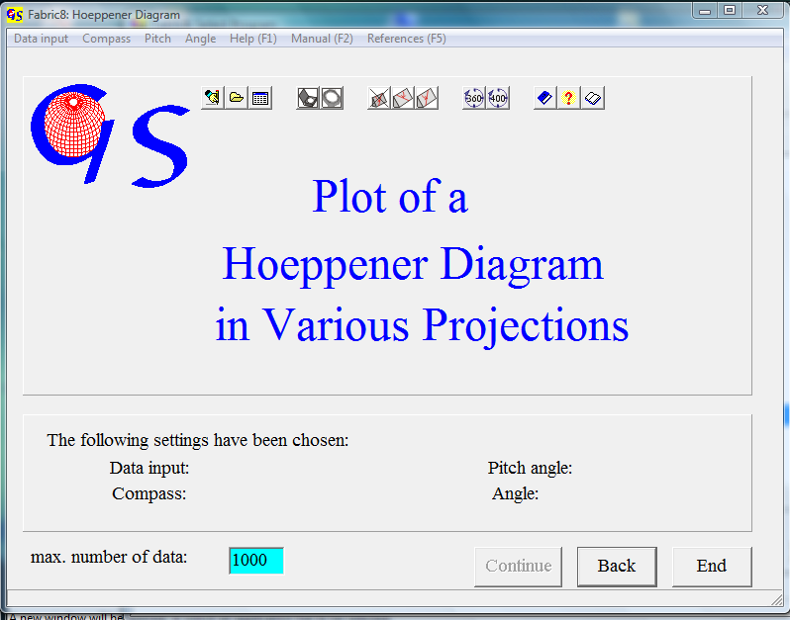Fig. 1

This program (Fig. 1) plots displacement data in a Hoeppener diagram (HOEPPENER, 1955). The slickenside plane is regarded as a tangent plane to the projection globe. The striation lineation is drawn as an arrow through the tangent point. This arrow describes the movement of the hanging block.
Manual data input and input from a file are the same as in program 11.

Fig. 2 shows the graphic form. The dots represent the normals to the slickenside planes, and the arrows are the displacement directions. The menu “Slip lines” (Fig. 3) plots theoretical slip lines. With the option ‘Slip lines/yes’ the field “Principal stresses” becomes active . Fill in the directions of σ₁ and σ₃ which can be found with program 11.
The shape factor of the stress ellipsoid is defined as.

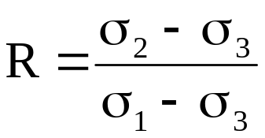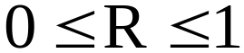
If R is known, all theoretical orientations of the striation lineations on the slickenside planes can be calculated (BOTT 1959), so it is possible to draw the theoretical orientations of striation lines (slip lines) for given principal stress directions and a given R-value.
By comparison of the data with these slip lines it becomes clear which data are obviously wrong, because they are not parallel to the slip lines.
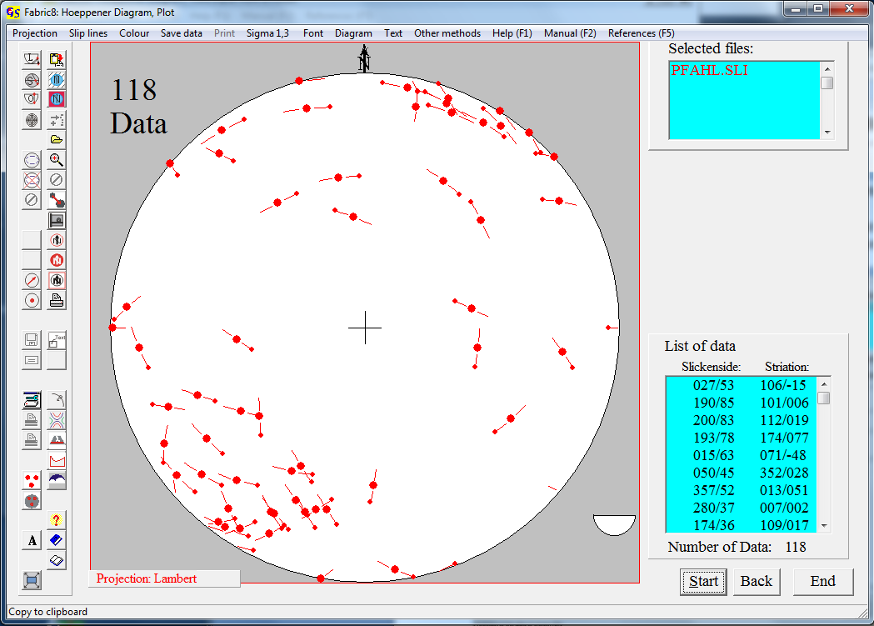
Fig. 2

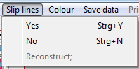
Fig. 3

All displacement data can be checked one after the other and erased if necessary. The remaining data can be saved with a new file name.
Fig. 4 shows theoretical orientations of striation lines (hatched lines) with the assumption that these are the maximum resolved shear stresses. The calculation was carried out for a number of 360 evenly distributed slickenside planes (Wallbrecher et al.,1996). In this example the lowest value of R is 0.0 (blue) and the highest value is R=0.5 (red), i.e. for these principal stresses all possible directions of arrows must be in the angles between the two striation trajectories. The slip line trajectories are drawn after input of the principal stresses, clicking on "OK", and clicking on the lowest and highest estimated shape factors. With "Slip lines/no" they can be erased.

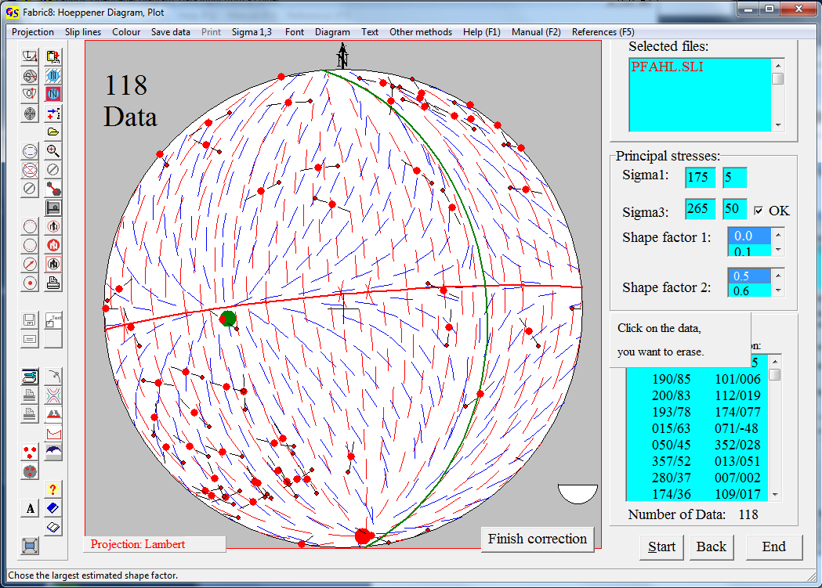Fig. 4

Clicking on those data which lie outside the trajectories eliminates them. This process is terminated by pressing the button “Finish correction”. Now the menu "Save data“ (Fig. 5) is active. Both groups of data, the cleaned group and the erased group can be saved.

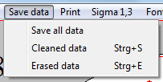
Fig. 5

This makes sense, because the erased data may belong to a different tectonic event. The same procedure is used for printing of data (Fig. 6).

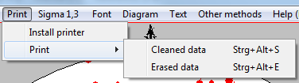
Fig. 6

The menu "Diagram" is described in program 3.
With the menu "Other methods" you can jump to one of the other programs which uses displacement data.

